# Experiment No :08

# 

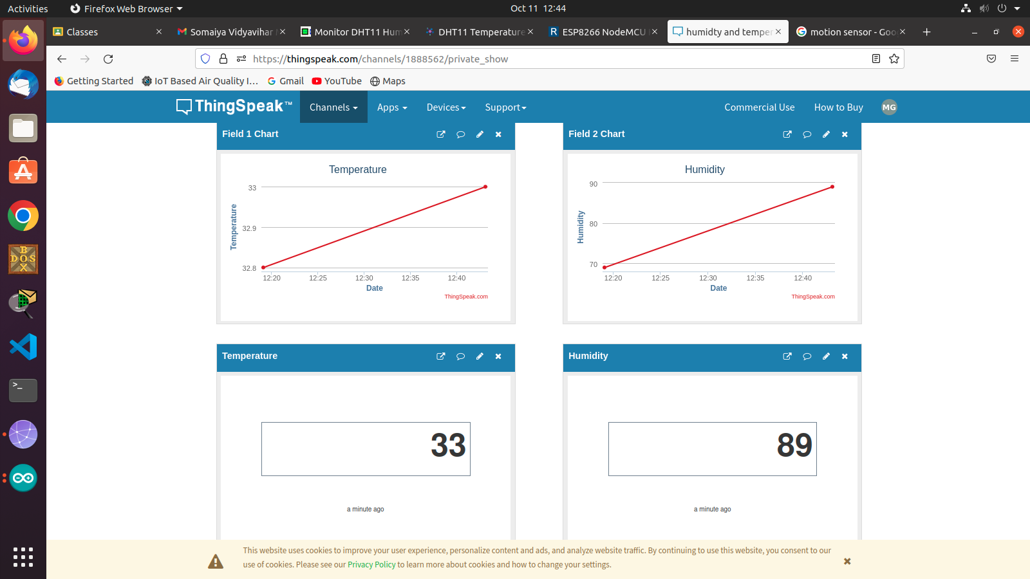

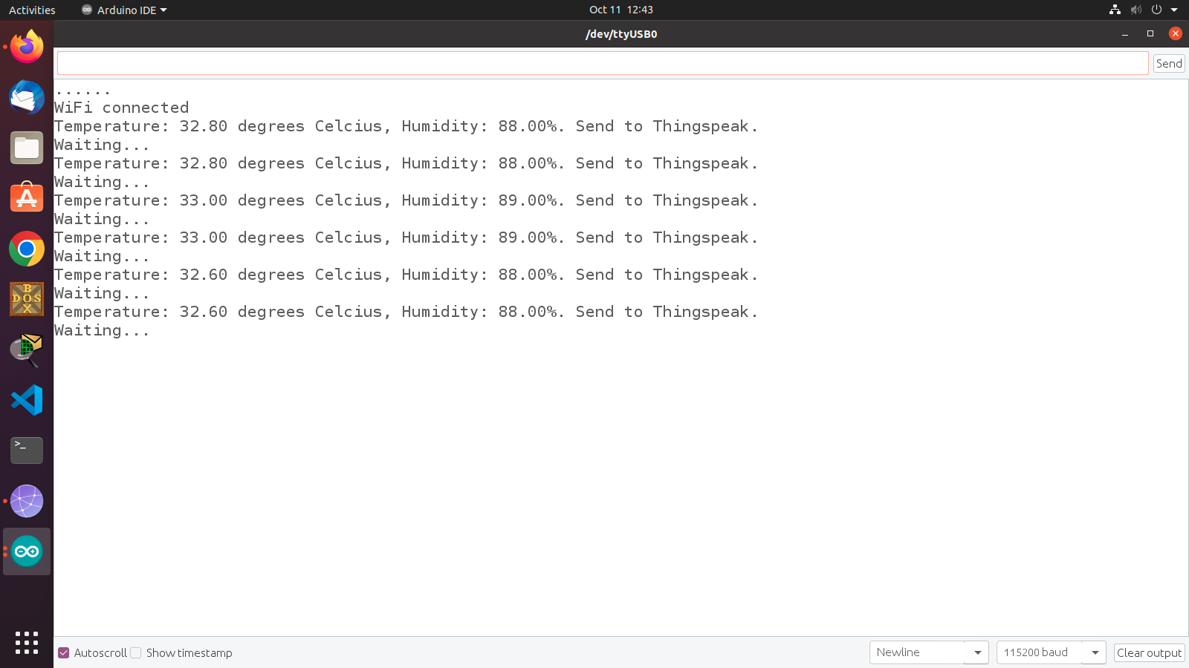

Code :

#include <DHT_U.h>

#include <DHT.h>

#include <DHT.h> // Including library for dht

#include <ESP8266WiFi.h>

String apiKey = "ZNIZ1OI58L7POGK3 "; // Enter your Write API key from ThingSpeak

const char *ssid = "lelebhai"; // replace with your wifi ssid and wpa2 key

const char *pass = "milan1234";

const char* server = "[api.thingspeak.com](http://api.thingspeak.com)";

#define DHTPIN 0 //pin where the dht11 is connected

DHT dht(DHTPIN, DHT11);

WiFiClient client;

void setup() {

Serial.begin(115200);

delay(10);

dht.begin();

Serial.println("Connecting to ");

Serial.println(ssid);

WiFi.begin(ssid, pass);

while (WiFi.status() != WL_CONNECTED)

{

delay(500);

Serial.print(".");

}

Serial.println("");

Serial.println("WiFi connected");

}

void loop() {

float h = dht.readHumidity();

float t = dht.readTemperature();

if (isnan(h) || isnan(t))

{

Serial.println("Failed to read from DHT sensor!");

return;

}

if (client.connect(server,80)) // "184.106.153.149" or [api.thingspeak.com](http://api.thingspeak.com)

{

String postStr = apiKey;

postStr +="&field1=";

postStr += String(t);

postStr +="&field2=";

postStr += String(h);

postStr += "\r\n\r\n";

client.print("POST /update HTTP/1.1\n");

client.print("Host: [api.thingspeak.com](http://api.thingspeak.com)\n");

client.print("Connection: close\n");

client.print("X-THINGSPEAKAPIKEY: "+apiKey+"\n"); client.print("Content-Type: application/x-www-form-urlencoded\n"); client.print("Content-Length: ");

client.print(postStr.length());

client.print("\n\n");

client.print(postStr);

Serial.print("Temperature: ");

Serial.print(t);

Serial.print(" degrees Celcius, Humidity: ");

Serial.print(h);

Serial.println("%. Send to Thingspeak.");

}

client.stop();

Serial.println("Waiting..."); updates delay(1000);

}